Moose Activity and Habitat Selection during Extreme Weather Events

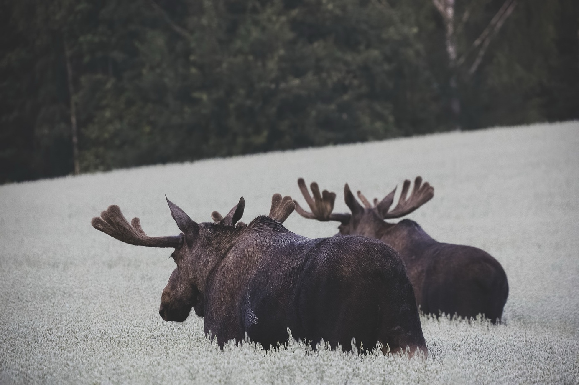

A joint thesis project between Wageningen University (WUR) and the Swedish University of Agricultural Sciences (SLU).
Student | WUR Supervisor | SLU Supervisor | SLU Examiner
Niels van der Vegt | Sytze de Bruin | Wiebke Neumann | Tim Hofmeester
niels.vandervegt@wur.nl | sytze.debruin@wur.nl | wiebke.neumann@slu.se | tim.hofmeester@slu.se
+31637340507 | +31317481830 | +46907868117 | +46907868307

Introduction

Climate change is projected to disrupt climactic stability and escalate the frequency and intensity of extreme weather events such as heatwaves, freeze-thaw cycles, droughts, floods, and storms (Medicine et al., 2016; Mellander et al., 2007). This unsettling trajectory bestows new challenges on animals that are well adapted to specific environmental niches, having already resulted in range shifts, diminished fitness, or even extinction of species (Parmesan & Yohe, 2003; Thomas et al., 2004; Zimova et al., 2016). The European moose (Alces alces) is an example of a species that has evolved to the cold and stable climatic environments prevalent in the boreal and (sub) arctic regions of the world. Nowadays, the northern ungulate is increasingly confronted with the external conditions of a less temperate climate. Weather fluctuations can directly and indirectly influence moose fitness. An example of a direct impact is dry, hot springs causing reduced fecundity and calf body mass in Swedish moose (Holmes et al., 2021). Indirect repercussions can manifest as reduced access to foraging habitat due to ground-icing after a freeze-thaw cycle, or habitat destruction after a major storm (Abernathy et al., 2019).
Fortunately, animals possess remarkable capacity to adapt to shifting environments, and can often do so by migrating, seeking alternative habitats, or adjusting behaviour — a phenomenon termed phenotypic plasticity. Moose too, exhibit the adaptive flexibility to navigate changing ecological dynamics. For instance, as heat-stress increases, moose exhibit a preference for mature coniferous forest habitats over young successional forests, prioritizing thermal shelter over foraging quality (van Beest et al., 2012). Significantly, individuals displaying thermoregulatory behaviours amidst heat stress tended to exhibit improved body conditions compared to individuals that did not exhibit such behaviour (van Beest & Milner, 2013).
Nevertheless questions linger as to whether species can adapt fast enough to keep up with their changing environments (Visser, 2008). Given the anticipated surge in extreme weather occurrences, the significance of regulatory behaviours in facilitating adaptation cannot be overstated. Changes in behavioural patterns, even when beneficial for individual fitness, may inadvertently side line other vital activities such as foraging or parental care (Cunningham et al., 2021). Furthermore, there are broader considerations beyond just adaptation rates, which encompass shifts in species interactions and ecosystem structures. Alterations in habitat preferences and time budgets could bear important ramifications for individual fitness, ecosystem dynamics, and human-wildlife conflicts—ranging from damage to managed forestry to increased road collisions (Edenius et al., 2002; Neumann et al., 2013).
To gain further insight into these impacts, a comprehensive understanding of the interplay between weather patterns, moose behaviour, and habitat selection is required. Such insights will not only illuminate the intricacies of species resilience in the face of climate change but also provide guidance for conservation efforts and management strategies.

Research needs

There exists a modest body of research on the effects of extreme weather on ungulates, particularly on species other than moose. These studies can provide insights into how moose might adapt to such conditions. However, it's important to note that most studies examining extreme weather events are opportunistic due to the inherent rarity of these events, relying on data from ongoing observational studies or monitoring initiated after recognizing climactic extremities (Smith, 2011).
An example is the aforementioned study by van Beest et al. (2012) which observed changes in habitat selection by southern Norwegian moose populations as a thermoregulatory response to high temperatures. Opportunistic studies have also been able to quantify an impact of storms on ungulates. Abernathy et al. (2019) found that white-tailed deer responded to the extreme winds and flooding caused by hurricane Irma by seeking refuge in higher elevation forests. However, as hurricanes were common in the studied region, this behaviour may represent an already existing adaptation to recurrent stormy conditions, rather than an adaption to an unprecedented extreme event. Lastly, Loe et al. (2016) investigated the space use of wild reindeer in Svalbard following freeze-thaw cycles and rain-on-snow events. These events can lead to ground icing, disrupting access to foraging sites by covering grazing patches with ice. The study found that wild reindeer displaced to areas with less ice during such events, resulting in improved body condition and reproductive success. While moose predominantly browse woody plants rather than graze like reindeer, it’s plausible that they may displace in a similar fashion when faced with freeze-thaw cycles due to increased foraging costs associated with traversing an ice-covered landscape.
The current knowledge gap regarding moose responses to specific climactic conditions underscores the need for large-scale studies. Fortunately, there exists a vast database of moose GPS locations in Sweden, collected across various climatic conditions. Leveraging this data allows for an opportunistic study on a broader scale, encompassing different populations across latitudes. The results of which may provide valuable insights into how moose respond to extreme weather events.

Overall research aims and research hypotheses

This study aims to provide novel insights into how extreme weather influences the behaviour and habitat preferences of European moose. Moose populations are abundant in Sweden and are carefully managed to mitigate road collisions, forestry damage, and agricultural conflicts (Lavsund et al., 2003). Changes in behaviour and habitat selection could have significant implications for both future moose management strategies and the coexistence of humans with moose. I will first consider the following hypotheses:
- In periods of extreme temperatures, moose are anticipated to adjust their activity patterns, reducing daytime foraging, and increasing activity during twilight and nighttime hours. This behavioural shift is expected to intensify with increasing latitude as northern moose are physiologically more cold adapted.
- During extreme temperature events, moose are expected to show a preference for mature forests that offer thermal cover, aiding in their thermoregulation efforts.
- In the face of extreme winds, moose will favour to seek shelter in mature forests during winter, but favour open environments in summer, letting the wind aid in conductive and evaporative cooling.
- When confronted with freeze-thaw cycles, moose are expected to decrease their transit behaviour due to the challenges and costs associated with navigating a landscape covered in ice.
Rejecting or providing support for these hypothesises can help predict how moose populations may respond to future climate change and would aid in effective conservation and wildlife management strategies.

Methodology

The study will be based on the Swedish moose tracking data available in the Wireless Remote Animal Monitoring (WRAM) database (Dettki et al., 2013). The dataset comprises 780 individual moose tracked across Sweden from 2003 to 2024, with a total of 1.602.094 GPS localizations. Tagged moose are equipped with collars that log a position every 3 hours using GPS localisation. Furthermore, they contain a temperature sensor which can serve as an index of ambient temperature (Ericsson et al., 2015). Some collars are also equipped with accelerometers.
We'll utilize historical weather data sourced from the Swedish Meteorological and Hydrological Institute (SMHI) weather stations. These weather stations are spread throughout Sweden and their data is accessible through an openly available API. To retrieve the weather station data efficiently, we'll develop a custom Python library using the aiohttp package. To identify periods of extreme weather, we will employ the methodology established by Holmes et al. (2021) , which involves examining historical weather records for each county in Sweden. Instances where temperature, precipitation, or wind measurements exceed the 95th percentile for that day in that county will be designated as extreme weather events. To define freeze-thaw cycles, I will identify days characterized by temperatures rising above freezing during the day and dropping below freezing at night. If these cycles occur frequently, I will refine this criterion by adjusting the temporal window or considering larger temperature variations. Subsequently, I will isolate the localisations of moose that traverse counties during these extreme weather events. Though the division into counties is purely artificial, I think this approach adequately addresses the typical spatial variations in weather across Sweden. Subsequently, we will analyse activity patterns and habitat selection during these flagged events of extreme weather and juxtapose them with those observed under typical weather conditions.

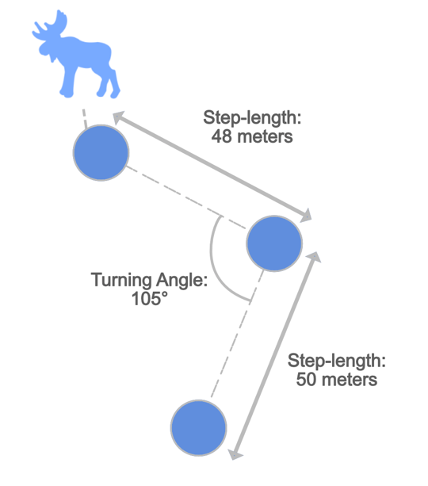
Activity Patterns
To see if moose change their activity patterns in response to extreme weather, we need to predict their behaviour from GPS localisations. Hidden Markov Models, a type of unsupervised machine learning, have been used extensively for this purpose on movement data (Langrock et al., 2012). GPS localisations and accelerometer data can be used to make an inference about the movement characteristics of an animal. Such characteristics include the distance travelled (step-length), linearity of the path (turning-angle / tortuosity), and velocity (Edelhoff et al., 2016). For example, the step length and turning angle can be approximated by taking the distance a moose travels between two consecutive GPS localisations and the angle taken between three GPS localisations respectively (Fig 1). Movement characteristics can in turn be used to predict animal behaviour, and have been used to predict transit, encamped, or foraging behaviour in a wide range of species (Edelhoff et al., 2016). Essentially, HMMs deduce a state that is not directly observable (referred to as a hidden state) from a set of observed variables that offer inference into this state. For instance, HMMs can predict an animal's behaviour, which is not directly observable, based on variables such as step-length and turning angle, which are observable through animal telemetry (McClintock & Michelot, 2018). I will employ the momentuHMM R package, developed by McClintock & Michelot (2018) to predict encamped or transit behaviour in moose based on their movement characteristics. These behavioural predictions will be used to shed light on hypotheses I and IV, which explore changes in activity patterns during extreme temperature events and freeze-thaw cycles. Furthermore, behavioural predictions will be integrated into the habitat selection analysis, as elaborated upon below.
Figure 1: Schematic displaying how step length and turning angle are calculated. Step length is the distance between two GPS localizations, turning angle is the angle taken between three localizations.

Habitat Selection
Through habitat selection analysis, I aim to explore whether moose demonstrate preferences for specific habitats during extreme weather conditions as a means of adapting to challenging environments. Step Selection Functions (SSFs) stand as a common statistical framework for studying habitat selection based on animal telemetry data. SSFs try to offer insight into why animals choose certain locations or paths over others, based on explanatory variables such as environmental characteristics and animal behaviour (Avgar et al., 2016; Thurfjell et al., 2014).
SSFs analyse the steps an animal takes between two locations, considering factors at both the starting and ending points of each step. They explore the relationship between these points through generalized linear models, seeking to predict the likelihood of an animal moving to a particular location based on the values of explanatory factors (Thurfjell et al., 2014). For instance, the likelihood of a moose moving to a mature coniferous forest on a hot, dry, wind still day. In my analysis, the observed steps serve as the response variable, while weather variables will act as predictors. To assess whether these habitat preferences are stronger than expected by random chance alone, SSFs compare observed steps to random steps generated as a null model (Thurfjell et al., 2014).
Additionally, by integrating behavioural predictions from Hidden Markov Models (HMMs) into SSFs it’s possible to account for the influence of behaviour on habitat selection. This is often significant as it’s common for animals to select different habitats and take different steps depending on their behaviour (Beumer et al., 2023). A more comprehensive analysis can be carried out by drawing the random steps from movement characteristics specific to the behaviour displayed, and by incorporating the predicted behaviour into the explanatory factors.
To define different habitats, I will utilize the national landcover database, maintained by the Swedish Environmental Protection Agency. Specifically, we will consider habitats conducive to moose foraging and encampment behaviours, such as mature or successional coniferous or deciduous forests. To facilitate the statistical modelling of SSFs the Animal Movement Tools (amt) R package will be used . The results of which can be used to investigate hypotheses II and III.

Time schedule

Figure 2 provides a preliminary planning of the activities carried out during this thesis project. As I am following a double-master I would prefer not to have my grade registered after the final examination, which is planned around July. This would prevent having to pay additional costs when I finish my second master next academic year.

Figure 2: preliminary planning of the activities carried out during the research project.

Feasibility

The rarity of extreme weather events poses a significant hurdle. These events occur infrequently, making it challenging to collect sufficient data to draw meaningful conclusions. Although the amount of data is vast compared to other studies looking at the effects of weather on ungulates, the study will inherently be opportunistic, and the statistical power of the findings may be limited by the amount of data available.
Secondly, determining which windows of time to compare presents another obstacle. Splitting the data into subsets to differentiate between variables such as gender, geographic location (northern vs. southern populations), and seasonal responses (summer vs. winter) adds complexity to the analysis. Yet this segmentation is crucial for capturing the nuanced variations in moose behavior across different contexts.

References
Abernathy, H. N., Crawford, D. A., Garrison, E. P., Chandler, R. B., Conner, M. L., Miller, K. V., & Cherry, M. J. (2019). Deer movement and resource selection during Hurricane Irma: Implications for extreme climatic events and wildlife. Proceedings of the Royal Society B: Biological Sciences, 286(1916), 20192230. https://doi.org/10.1098/rspb.2019.2230

Avgar, T., Potts, J. R., Lewis, M. A., & Boyce, M. S. (2016). Integrated step selection analysis: Bridging the gap between resource selection and animal movement. Methods in Ecology and Evolution, 7(5), 619–630. https://doi.org/10.1111/2041-210X.12528

Beumer, L. T., Schmidt, N. M., Pohle, J., Signer, J., Chimienti, M., Desforges, J.-P., Hansen, L. H., Højlund Pedersen, S., Rudd, D. A., Stelvig, M., & van Beest, F. M. (2023). Accounting for behaviour in fine-scale habitat selection: A case study highlighting methodological intricacies. Journal of Animal Ecology, 92(10), 1937–1953. https://doi.org/10.1111/1365-2656.13984

Cunningham, S. J., Gardner, J. L., & Martin, R. O. (2021). Opportunity costs and the response of birds and mammals to climate warming. Frontiers in Ecology and the Environment, 19(5), 300–307. https://doi.org/10.1002/fee.2324

Dettki, H., Ericcson, G., Giles, T., & Norrsken-Ericsson, M. (2013). Wireless Remote Animal Monitoring (WRAM)—A new international database e-infrastructure for telemetry sensor data from fish and wildlife. In Proceedings Etc. 2012: Convention for Telemetry, Test Instrumentation and Telecontrol (pp. 247–256). The European Society of Telemetry.

Edelhoff, H., Signer, J., & Balkenhol, N. (2016). Path segmentation for beginners: An overview of current methods for detecting changes in animal movement patterns. Movement Ecology, 4(1), 21. https://doi.org/10.1186/s40462-016-0086-5

Edenius, L., Bergman, M., Ericsson, G., & Danell, K. (2002). The role of moose as a disturbance factor in managed boreal forests. Silva Fennica, 36(1). https://doi.org/10.14214/sf.550

Ericsson, G., Dettki, H., Neumann, W., Arnemo, J. M., & Singh, N. J. (2015). Offset between GPS collar-recorded temperature in moose and ambient weather station data. European Journal of Wildlife Research, 61(6), 919–922. https://doi.org/10.1007/s10344-015-0968-7

Holmes, S. M., Cromsigt, J. P. G. M., Danell, K., Ericsson, G., Singh, N. J., & Widemo, F. (2021). Declining recruitment and mass of Swedish moose calves linked to hot, dry springs and snowy winters. Global Ecology and Conservation, 27, e01594. https://doi.org/10.1016/j.gecco.2021.e01594
Langrock, R., King, R., Matthiopoulos, J., Thomas, L., Fortin, D., & Morales, J. M. (2012). Flexible and practical modeling of animal telemetry data: Hidden Markov models and extensions. Ecology, 93(11), 2336–2342. https://doi.org/10.1890/11-2241.1

Lavsund, S., Nygrén, T., & Solberg, E. J. (2003). STATUS OF MOOSE POPULATIONS AND CHALLENGES TO MOOSE MANAGEMENT IN FENNOSCANDIA. Alces: A Journal Devoted to the Biology and Management of Moose, 39, 109–130.

Loe, L. E., Hansen, B. B., Stien, A., D. Albon, S., Bischof, R., Carlsson, A., Irvine, R. J., Meland, M., Rivrud, I. M., Ropstad, E., Veiberg, V., & Mysterud, A. (2016). Behavioral buffering of extreme weather events in a high-Arctic herbivore. Ecosphere, 7(6), e01374. https://doi.org/10.1002/ecs2.1374

McClintock, B. T., & Michelot, T. (2018). momentuHMM: R package for generalized hidden Markov models of animal movement. Methods in Ecology and Evolution, 9(6), 1518–1530. https://doi.org/10.1111/2041-210X.12995

Medicine, N. A. of S., Engineering, and, Studies, D. on E. and L., Climate, B. on A. S. and, & Attribution, C. on E. W. E. and C. C. (2016). Attribution of Extreme Weather Events in the Context of Climate Change. National Academies Press.

Mellander, P.-E., Löfvenius, M. O., & Laudon, H. (2007). Climate change impact on snow and soil temperature in boreal Scots pine stands. Climatic Change, 85(1), 179–193. https://doi.org/10.1007/s10584-007-9254-3

Neumann, W., Ericsson, G., Dettki, H., & Radeloff, V. C. (2013). Behavioural response to infrastructure of wildlife adapted to natural disturbances. Landscape and Urban Planning, 114, 9–27. https://doi.org/10.1016/j.landurbplan.2013.02.002

Parmesan, C., & Yohe, G. (2003). A globally coherent fingerprint of climate change impacts across natural systems. Nature, 421(6918), Article 6918. https://doi.org/10.1038/nature01286

Signer, J., Fieberg, J., & Avgar, T. (2019). Animal movement tools (amt): R package for managing tracking data and conducting habitat selection analyses. Ecology and Evolution, 9(2), 880–890. https://doi.org/10.1002/ece3.4823

Smith, M. D. (2011). An ecological perspective on extreme climatic events: A synthetic definition and framework to guide future research. Journal of Ecology, 99(3), 656–663. https://doi.org/10.1111/j.1365-2745.2011.01798.x

Thomas, C. D., Cameron, A., Green, R. E., Bakkenes, M., Beaumont, L. J., Collingham, Y. C., Erasmus, B. F. N., de Siqueira, M. F., Grainger, A., Hannah, L., Hughes, L., Huntley, B., van Jaarsveld, A. S., Midgley, G. F., Miles, L., Ortega-Huerta, M. A., Townsend Peterson, A., Phillips, O. L., & Williams, S. E. (2004). Extinction risk from climate change. Nature, 427(6970), Article 6970. https://doi.org/10.1038/nature02121

Thurfjell, H., Ciuti, S., & Boyce, M. S. (2014). Applications of step-selection functions in ecology and conservation. Movement Ecology, 2(1), 4. https://doi.org/10.1186/2051-3933-2-4

van Beest, F. M., & Milner, J. M. (2013). Behavioural responses to thermal conditions affect seasonal mass change in a heat-sensitive northern ungulate. PloS One, 8(6), e65972. https://doi.org/10.1371/journal.pone.0065972

van Beest, F. M., Van Moorter, B., & Milner, J. M. (2012). Temperature-mediated habitat use and selection by a heat-sensitive northern ungulate. Animal Behaviour, 84(3), 723–735. https://doi.org/10.1016/j.anbehav.2012.06.032

Visser, M. E. (2008). Keeping up with a warming world; assessing the rate of adaptation to climate change. Proceedings of the Royal Society B: Biological Sciences, 275(1635), 649–659. https://doi.org/10.1098/rspb.2007.0997

Zimova, M., Mills, L. S., & Nowak, J. J. (2016). High fitness costs of climate change-induced camouflage mismatch. Ecology Letters, 19(3), 299–307. https://doi.org/10.1111/ele.12568

